FINAL PROJECT - MOVIE ON DEMEND

Web Service and API Development 2020

x19175108 Geneci Ui Fhatharta

x19176414 Katarzyna Casserly

x19141815 Ronan Behan

x19139306 Rory Cleary

Contents

1 Introduction 3

1.1 Description of the project 3

1.2 Entity-Relationship diagram 4

2 Security concerns 4

2.1 API Security Concerns 4

2.2 Authentication 5

2.3 Authorization 5

2.4 Encryption 6

3 Restful API 6

4 Work breakdown 11

5 Web service operation 12

6 Reference

# Introduction

## Description of the project

The scope of this project is to design and implement an application that represents a movie on demand stream similar to Netflix, Amazon Prime and so on. The application is to be developed using the Java platform. Java is the most used programming language in the market. By learning how to develop such application in Java adds great values to our knowledge and curriculum.

The MovieOnDemand application has a class type List that holds a List of all customers and a List of all movies.

The MoviesOnDemand application contains a class to represent Customer instances, where the main household owner of the account can create different profiles for family members.

The application also holds a class with all movies available for customers account based on the account specificity. Account specificity is defined by the field famMemberCategory. This defines if account can be assigned to kids or teenagers or adults. Therefore the field age is important as we will use this field to limit the category access.

The Account class is between Customer and Movies. This class state to which category a family member is assigned to. In order to be able to access a Movie a family member need to have an account created. The family member account is created by the account owner.

To design such application our group first discussed the relationship between customer and account as well customer and the Movie list.

We also discussed how to make the application security to guarantee customer data protection and privacy.

The group also discussed and documented all type of APIs the application would need to guarantee access to data base on URL / URI. All APIs and URI are designed based on parameters and fields of the classes present on the ER diagram.

## Entity-Relationship diagram

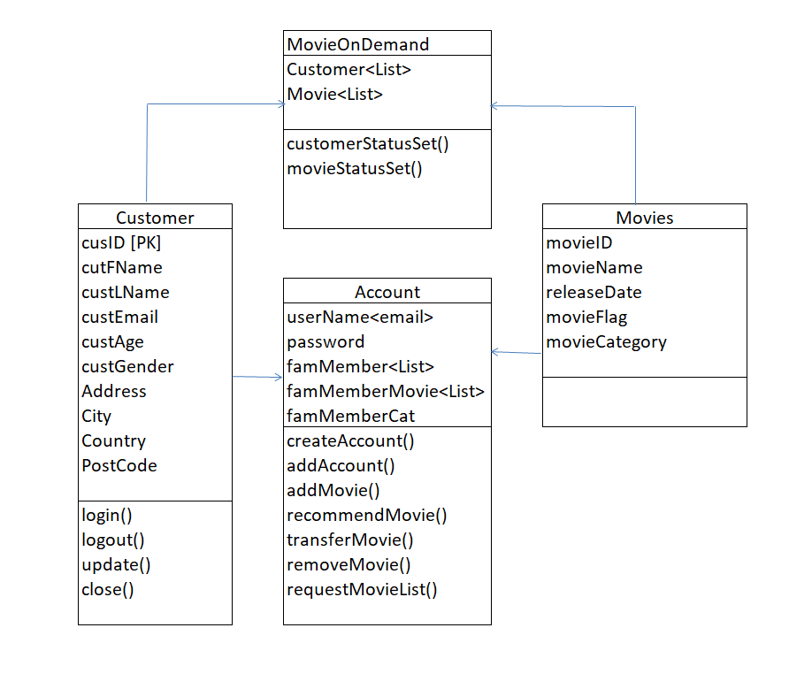

# Security concerns

## API Security Concerns

Cyber threats are a real problem in this digital age. Companies are being targeted for their valuable data and if these threats are found to have breached the security of the application, this can bring a whole new level of hassle and negativity to an entity.

Due to the meteoric rise of the internet and the differing services it encompasses, there is a constant sprint to build more suitable apps as speedily as possible. This is where API’s have come into their own and are being utilised more frequently to connect resources and to relocate data.

Unfortunately the downside to this is the fact that developers are being tasked with the implementation of these API’s with extreme haste. This can lead to certain applications not being secured or configured correctly and therefore allowing hackers to penetrate the API and cloning the sensitive data involved, sometimes exposing the personal data of millions of users.

It is important to ensure that all applications are secured to the highest standard across the whole internet. API’s are no different in this regard and developers must implement the requisite source code into their applications. Authorization, Authentication and Encryption are areas that must be concentrated on in this regard. Currently two-factor authentication and signing in through Apple, Google or Facebook are popular avenues for users to take.

Including a threat model into your development for an API should help reduce the risk posed by unwanted DDoS attacks. These models can act as a protective screen around your API which will undoubtedly guard against such attacks and ensure that as time passes, an ongoing risk analysis is performed on your API, reducing the chances of a disruption of service attack.

Java EE and JAX-RS offer a set of security protocols which can be accessed through a RESTful web service. Part of these protocols are Authentication and Authorization and Encryption.

## Authentication

In relation to authentication it is imperative that the server can verify the identity of the request that has been submitted from the client. This commonly requires confirming whether the client has issued the user a valid password. The Java EE servlet container includes resources that enable it to comprehend these authentication protocols and ensure that they are secure. For this project we propose to use Client Certificate Authentication. This method requires the use of the HTTPS protocol to secure your connection with a server. Digitally signed certificates will need to be signed from the server and the browser will ensure that these certificates are sent from a trusted source. As part of the PSD2 Strong Customer Authentication regulations, additional information will be required from a user to confirm their identity. Two-way authentication is the standard protocol used for this purpose. For instance as part of the logging in process, a user will usually be sent a code to either their phone or through an email account to verify that they are the registered owner of this account.

Below is the section of code that a developer would insert into the API to ensure that the authentication of the app is secured through the Client Certificate Authentication protocol.

**<login-config>**

**<auth-method>CLIENT_CERT</auth-method>**

**<realm-name>jaxrs</realm-name>**

**</login-config>**

## Authorization

After the authentication process is complete and the client has been verified, the client will need to link with the RESTful server. It will be the decision of the API administrator or team to determine what level of access and permissions each user be allowed, e.g. admin or user. All users will be assigned to a particular group, which will identify the role that each user is associated with. Permissions are able to be revoked and added as required.

## Encryption

Encryption and tokens are an industry standard in relation to the securing of personal data. It is vital for the developer to include some sort of strong encryption method in the application to secure users data. Cyber threats come in many forms and tend to target apps that store large amounts of sensitive and valuable data. The API needs to be secure and the requirement for a digital signature can verify that only an authorized account holder can access and adjust data. It is possible to increase the level of security within your application and change the default HTTP protocol to HTTPS. This ensures that higher encryption levels are implemented by default with Transport Layer Security (TLS) encryption.

A fundamental feature for securing an API is the required availability using authentication and authorization. Certain software packages are available for this purpose with one of the most popular being OAuth (Open Authorization). This token based framework ensures that data which is obtained by third parties does not reveal a user’s personal data.

# Restful API

|  |  |
| --- | --- |
| API Name: | Create account |
| Description | This allows the potential customer to register an account with this movie site. |
| URI: | /customer/register |
| HTTP | POST |
| Parameters | customerID (INT), customerDetails(String) |
| Resource contents | This is if the account is registered with the movie site or not |
| Pre-Conditions | Account must not exist, requires an email address |
| Post-Conditions | Filling in the details required to set up an account to rent movies |

|  |  |
| --- | --- |
| API Name: | Login |
| Description | This allows the customer to login to his account |
| URI: | /customer/login |
| HTTP | POST |
| Parameters | customerID (INT), password (String) |
| Resource contents | This if you are logged out and want to log in |
| Pre-Conditions | Account must exist, the name on the account must be correct, the password must be correct |
| Post-Conditions | Successful login |

|  |  |
| --- | --- |
| API Name: | Add family member |
| Description | This allows a current customer to register another account with this movie site for a family member. |
| URI: | /customer/add_account |
| HTTP | POST |
| Parameters | family_memID (INT required)  fam_memPassword (String), |
| Resource contents | This is if the customer wants to set up another account for a family member. |
| Pre-Conditions | Customer has an account, has a family member |
| Post-Conditions | Puts in enough details to allow the customer’s family member the ability to access the customer’s account with their own account details – name and password |

|  |  |
| --- | --- |
| API Name: | Add Movie |
| Description | This allows the customer to add a movie to their account |
| URI: | /customer/movieList/addMovie |
| HTTP | PUT |
| Parameters | customerID (INT required), movieID (INT) |
| Resource contents | This is if the customer wants to add a movie to their account temporarily or permanently |
| Pre-Conditions | Customer must have an account, customer must have payment details correct, customer must have available funds in his account, customer does not have the movie in question already |
| Post-Conditions | Customer successfully adds the movie to his account for a temporary or permanent period of time |

|  |  |
| --- | --- |
| API Name: | Transfer Movie |
| Description | Transfer Movie from the customer’s account to other account |
| URI: | /customer/moviesList/transfer |
| HTTP | PUT |
| Parameters | movieID (INT), customer_family_ID (INT, required), |
| Resource contents | This is if the customer has a movie which he wishes to send over to another account |
| Pre-Conditions | Has an account, this account is connected to the other account, has the movie he wants to send to the other account, the other account exists |
| Post-Conditions | The account connected to the customer’s account has received the film that the customer wanted to send over. |

|  |  |
| --- | --- |
| API Name: | Remove movie |
| Description | Function to remove movie from the account list |
| URI: | /customer/moviesList/delete |
| HTTP | DELETE |
| Parameters | customerID (INT), movieID (INT) |
| Resource contents | Confirmation of the movie removal, updated customer account listing |
| Pre-Conditions | Existing account, Existing movie in the movie listing |
| Post-Conditions | Updated account showing removed movie from the list |

|  |  |
| --- | --- |
| API Name: | List Existing Movies |
| Description | Display existing library of the loan movies |
| URI: | /customer/movieList |
| HTTP | GET |
| Parameters | customerID (INT), movieID( INT) |
| Resource contents | Display of the current list of the movies |
| Pre-Conditions | Has an account, has added movies in account |
| Post-Conditions | Displays a list of movie currently on the account |

|  |  |
| --- | --- |
| API Name: | History |
| Description | This allows the customer to view their viewing history |
| URI: | /customer/history |
| HTTP | GET |
| Parameters | customerID (INT), movieID (INT) |
| Resource contents | This allows the customer to see their viewing history |
| Pre-Conditions | Existing account, has movies that the customer has watched |
| Post-Conditions | Displays pages of the movies previously watched |

|  |  |
| --- | --- |
| API Name: | Search |
| Description | This allows the customer to search the movies list |
| URI: | /customer/movies/search |
| HTTP | GET |
| Parameters | customerID (INT), movieID (INT), movieName (String) |
| Resource contents | This function allows us to find a film we want from the movies on the movie site |
| Pre-Conditions | Existing account, Existing movie in movie directory |
| Post-Conditions | Searches for the film in question and if it exists; displays it |

|  |  |
| --- | --- |
| API Name: | Suggestions |
| Description | Display 5 random suggestions |
| URI: | /customer/movieList/randomSuggestion |
| HTTP | GET |
| Parameters | customerID (INT), movieID(INT) |
| Resource contents | Display 5 random movies |
| Pre-Conditions | Existing account, Existing movies in the movie listing, if customer doesn’t have 5, display whatever the customer has |
| Post-Conditions | Displays 5 random movies, if less than 5 movies on the account, displays what is there |

|  |  |
| --- | --- |
| API Name: | Freeze account |
| Description | Suspend account for 3 months and pause subscription fee |
| URI: | Customer/suspend |
| HTTP | POST |
| Parameters | customerID (INT), password (String) |
| Resource contents | Suspend user account short period |
| Pre-Conditions | Existing active account |
| Post-Conditions | Account is suspended , membership fee payment is freeze and user can’t rent/ view movies |

# Work breakdown

The work breakdown was as follows. We met regularly. We had many meeting since being given this project. For the report Kasia did the description of the problem and the proposed solution with the help of everyone. Geneci did the entity diagram. Rory did the security breakdown. Ronan did the work breakdown. Ronan and Kasia did the Restful API section. Ronan did the Web Service Operation and attached the pictures.

Everybody took part in the Working prototype. We met regularly and all provided input for the logic and helped each other build the classes.

Ronan an Genici did the Video Presentation as Kasia and Rory had personal reason why they weren’t able to commit to this minor aspect.

# Web service operation

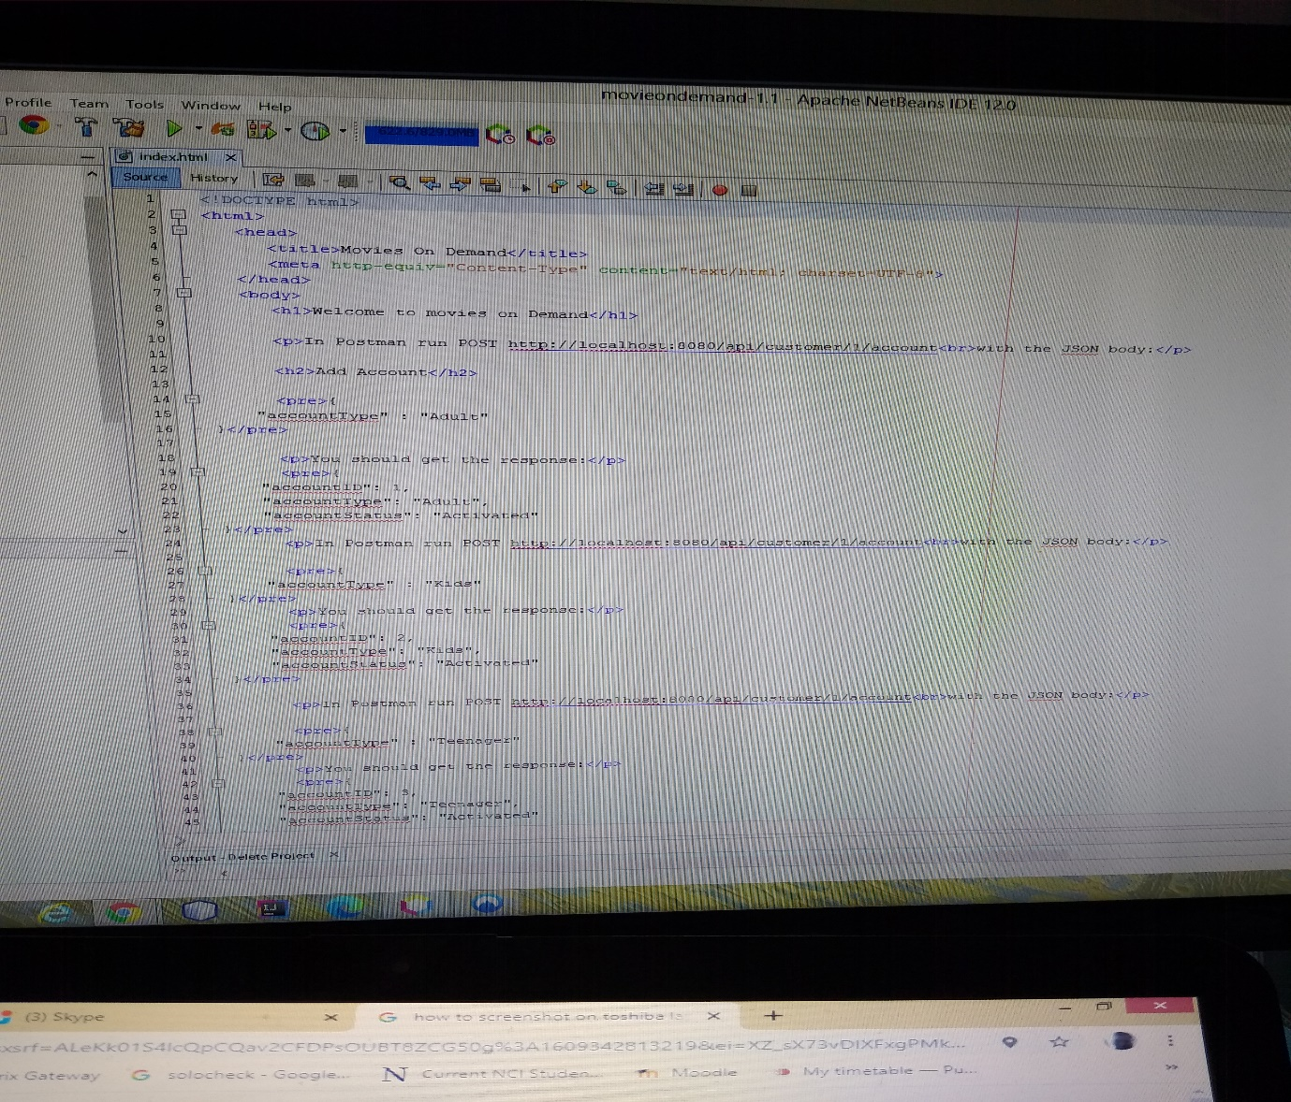

Here is the HTML. As you can see we have all the methods and the accompanying URLs.

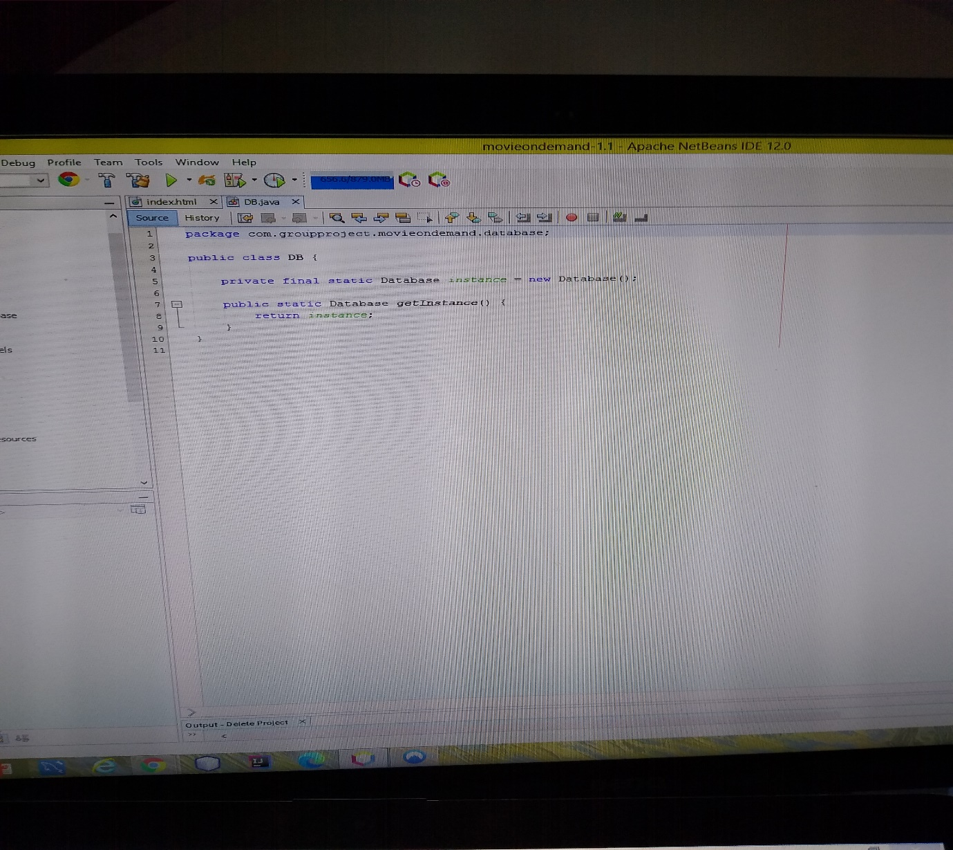

This is the instance of the Database.

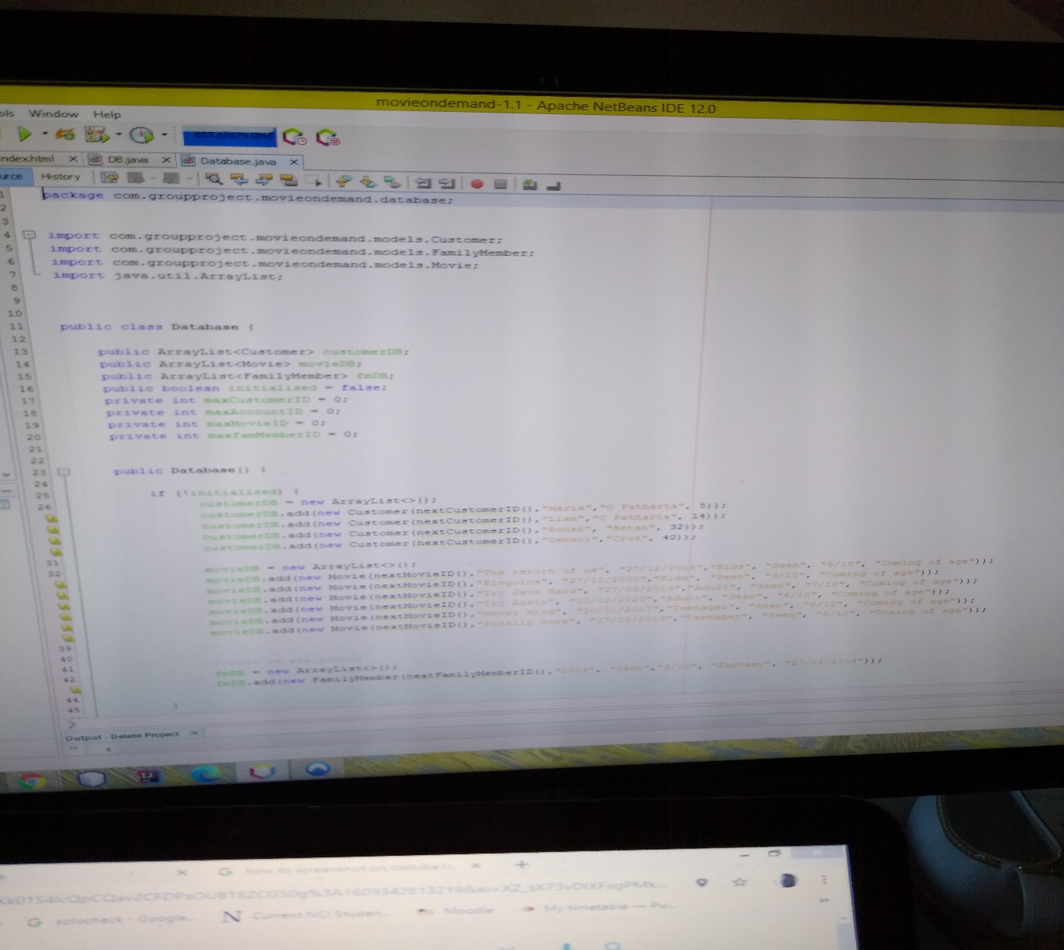

This is the database proper. There are all the array lists and methods for all the requirements. See below the continuation.

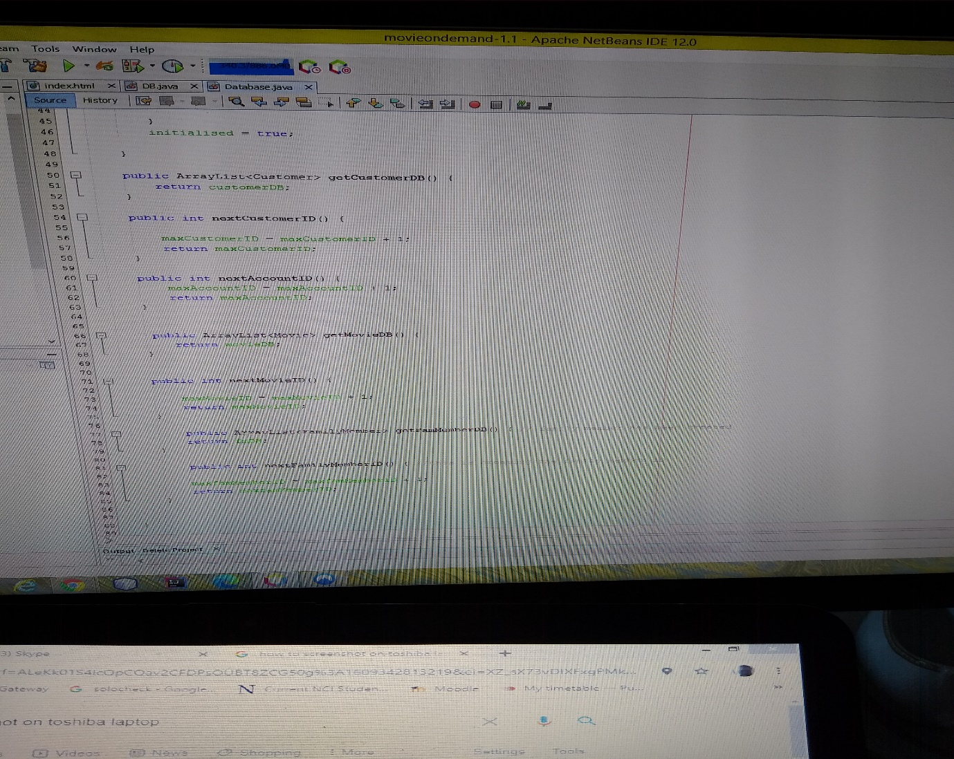

Next we will move onto the models. This is the account.

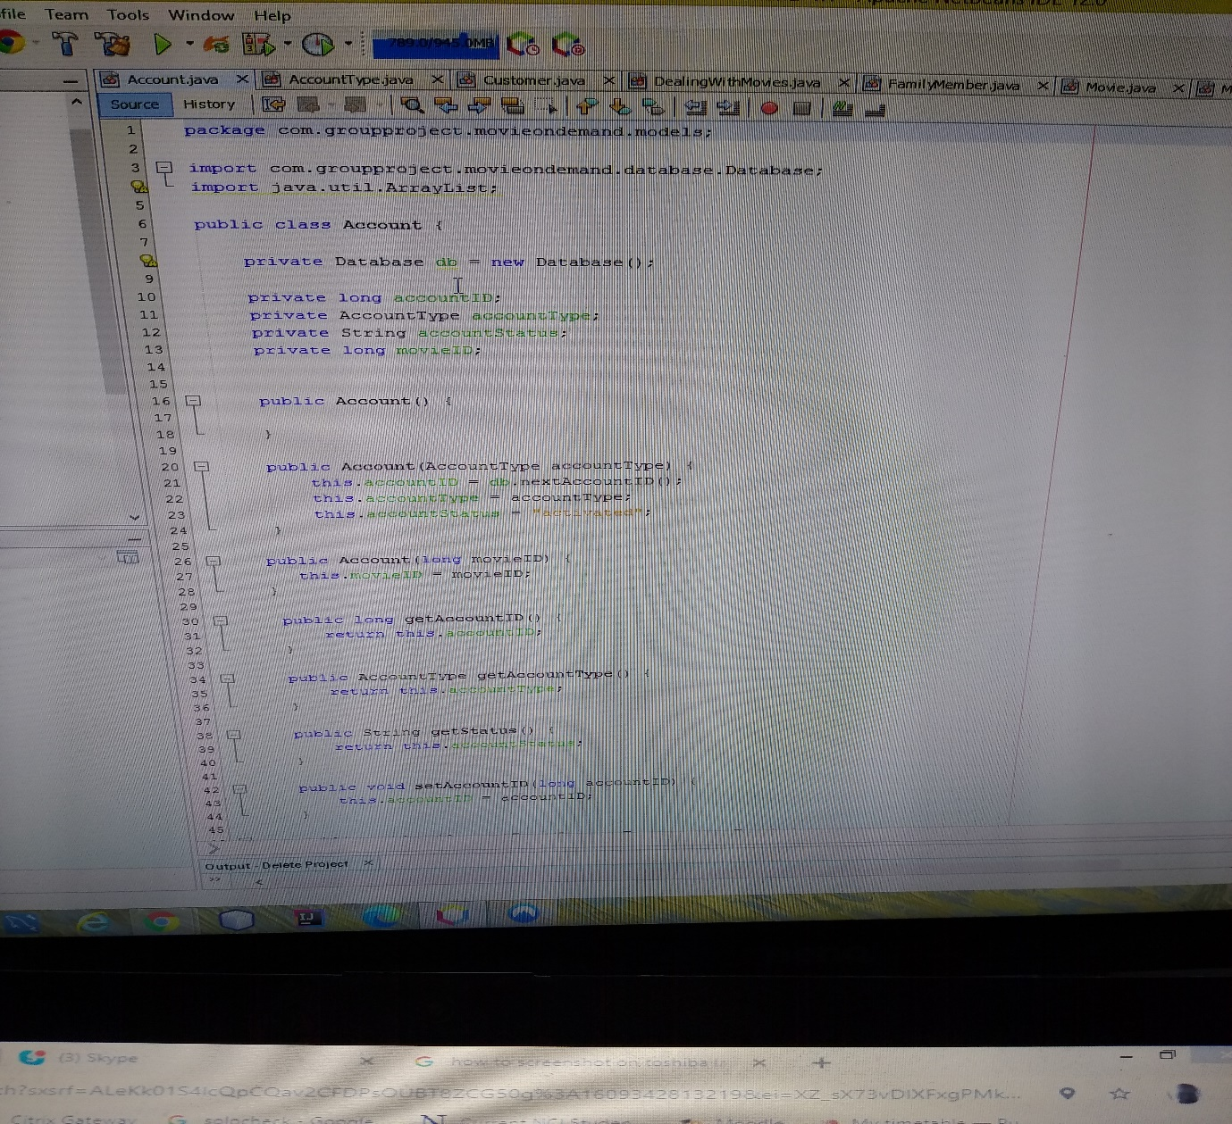

You can see the instance of the database. We have all the required variables for the account. We have all the constructors, setters and getters.

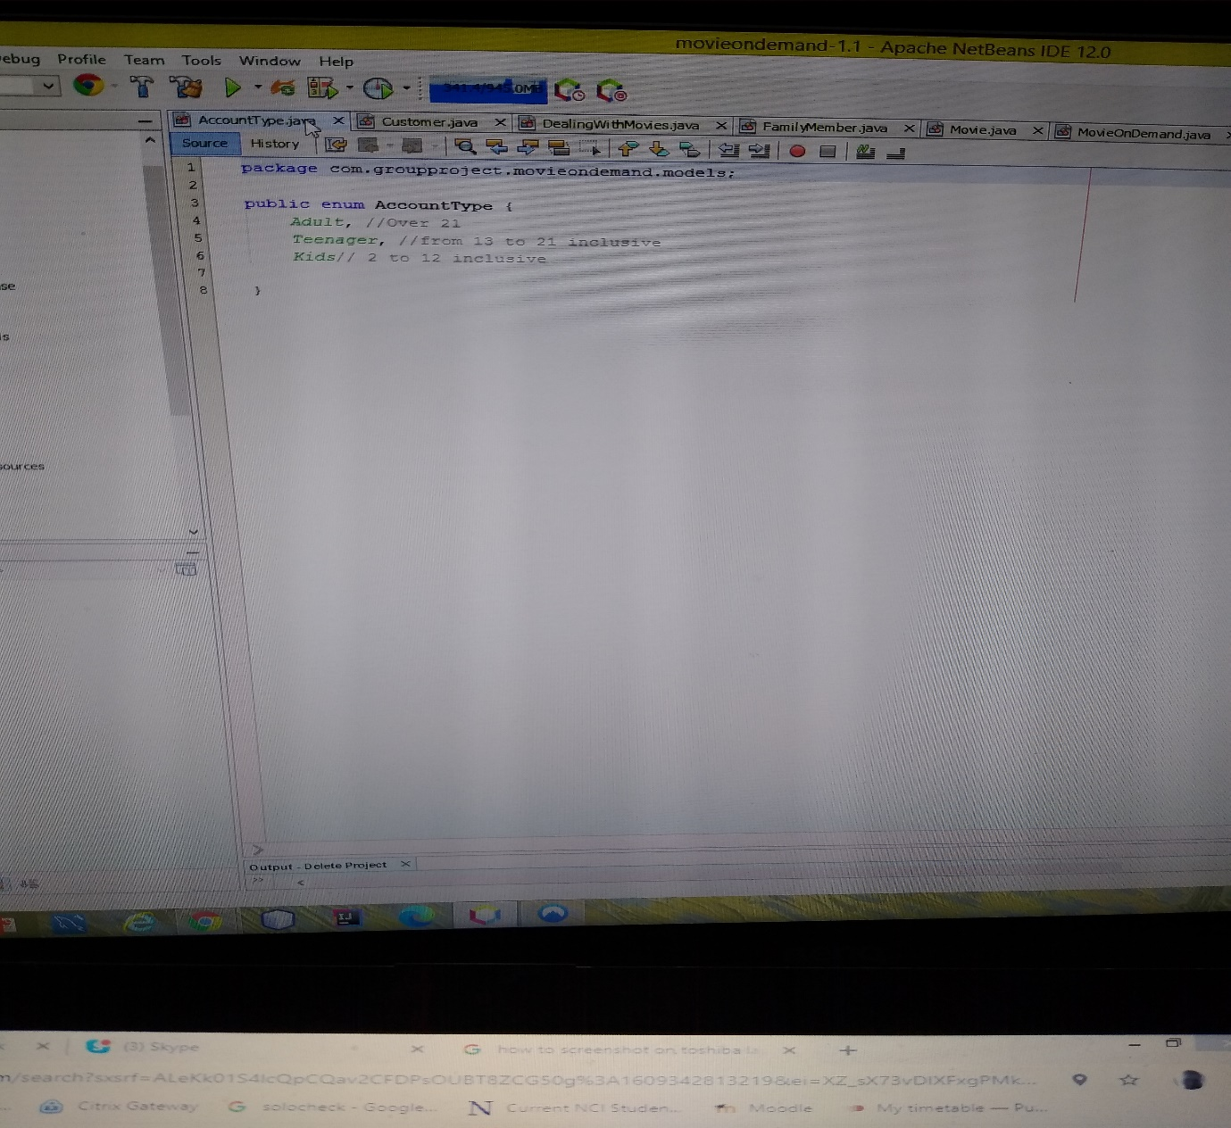

This is the AccountType class. This contains all the enumerated values for the Account.

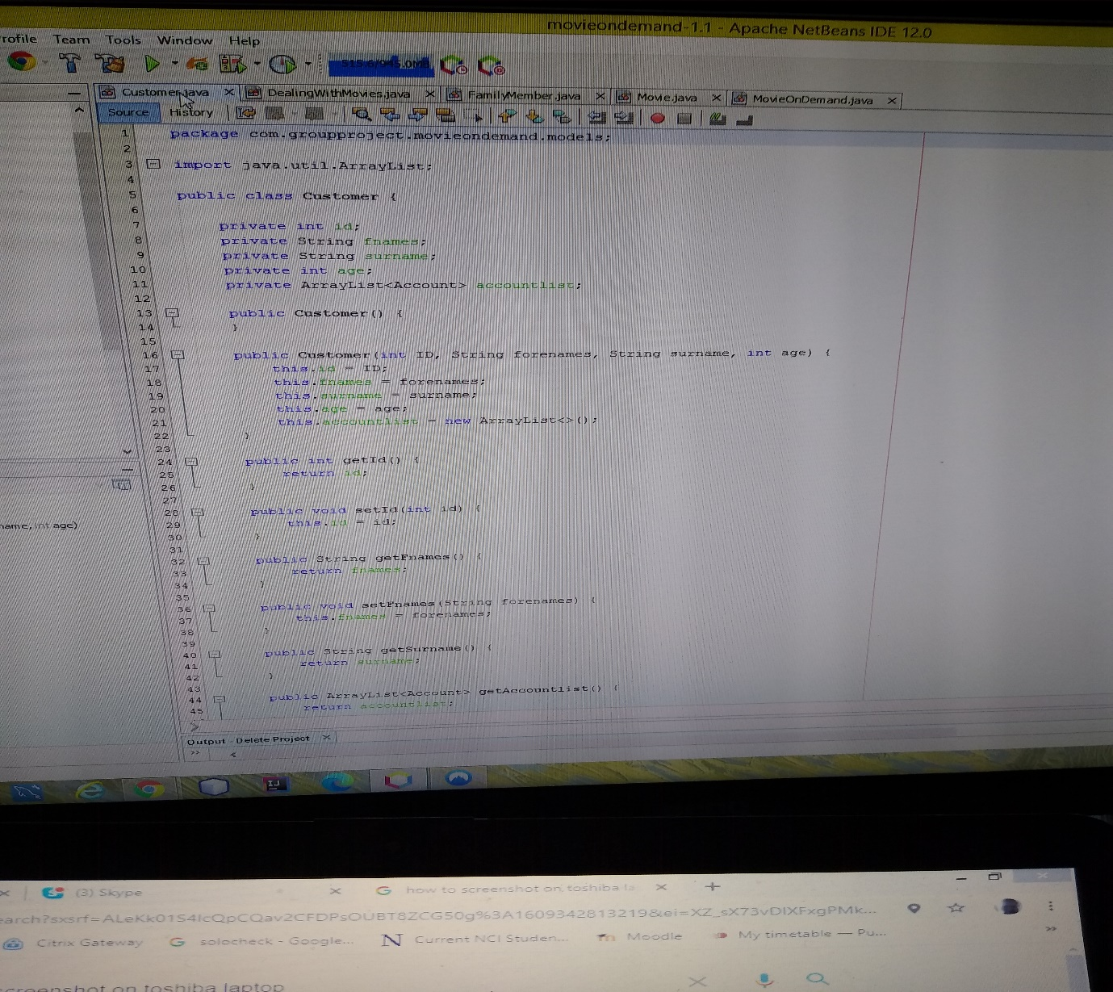

This is the customer class. Again we have all the variables for customer. The constructors, the setters and getters.

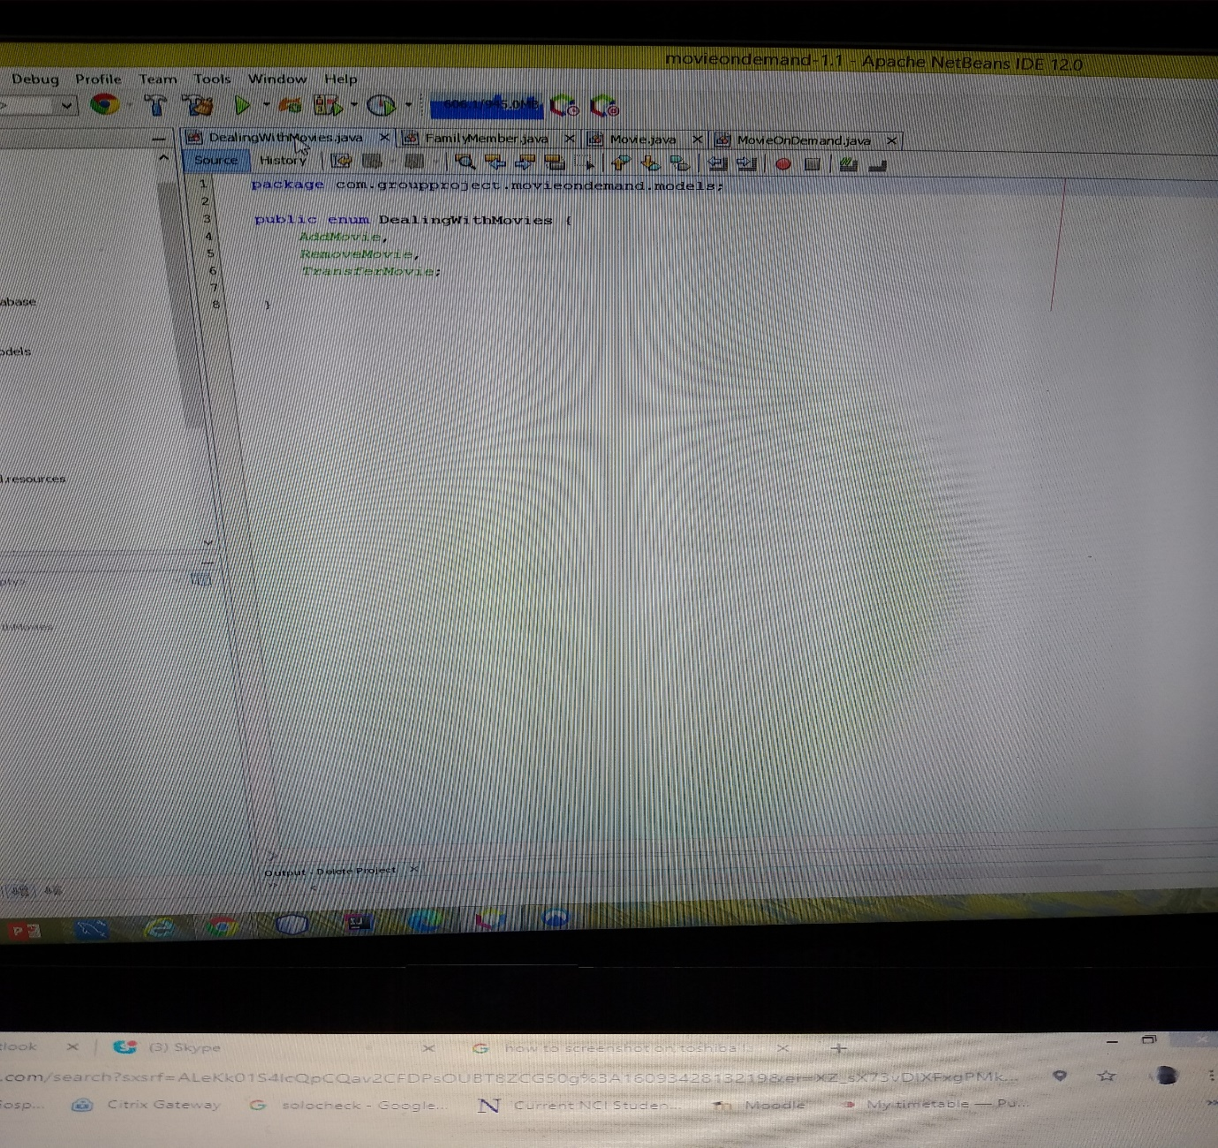

This is the enumerated values for the methods in Dealing with our movies. We can add, delete and transfer movies.

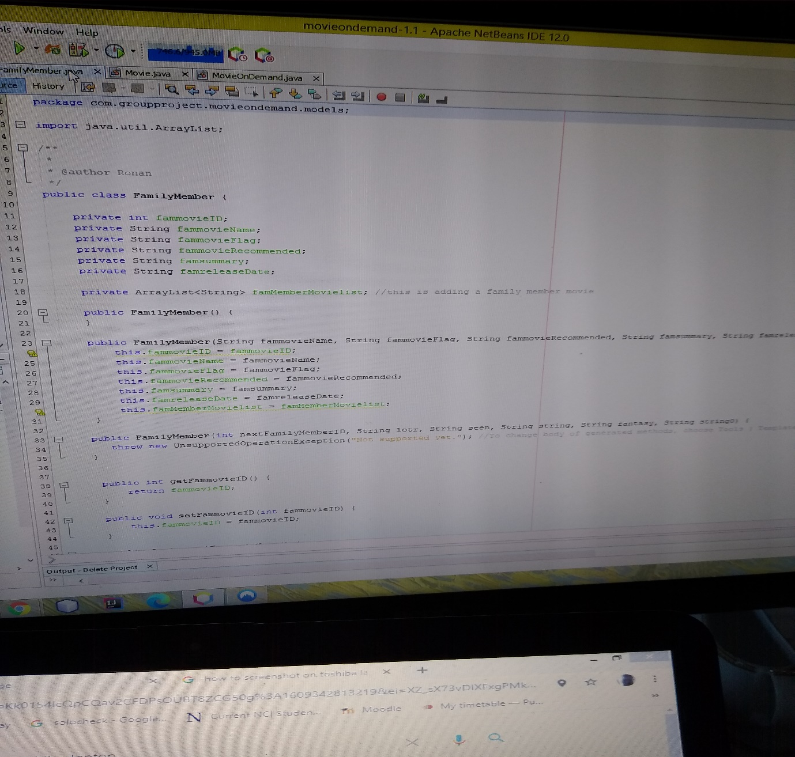

This class called family member is for the family member movies. It has all the variables required. It also has the array list for the family member movie list. It has all the required setters and getters.

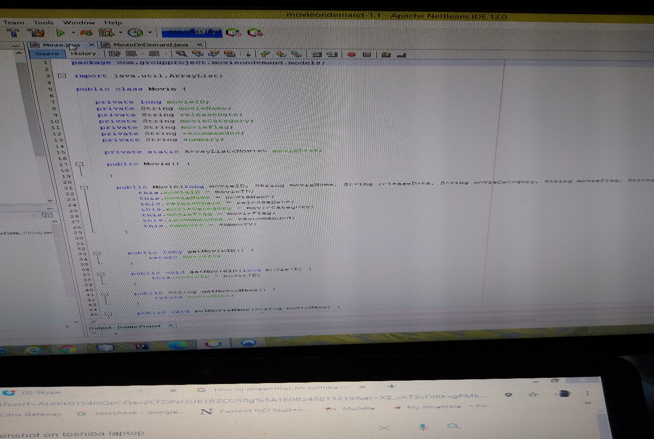

This is the Movie class. It contains all the variables required for our movies and the array list for our list of movies as well as the constructors, setters and getters.

Finally for the models we have MovieOnDemand. This contains the array list for the family member list and the customer list.

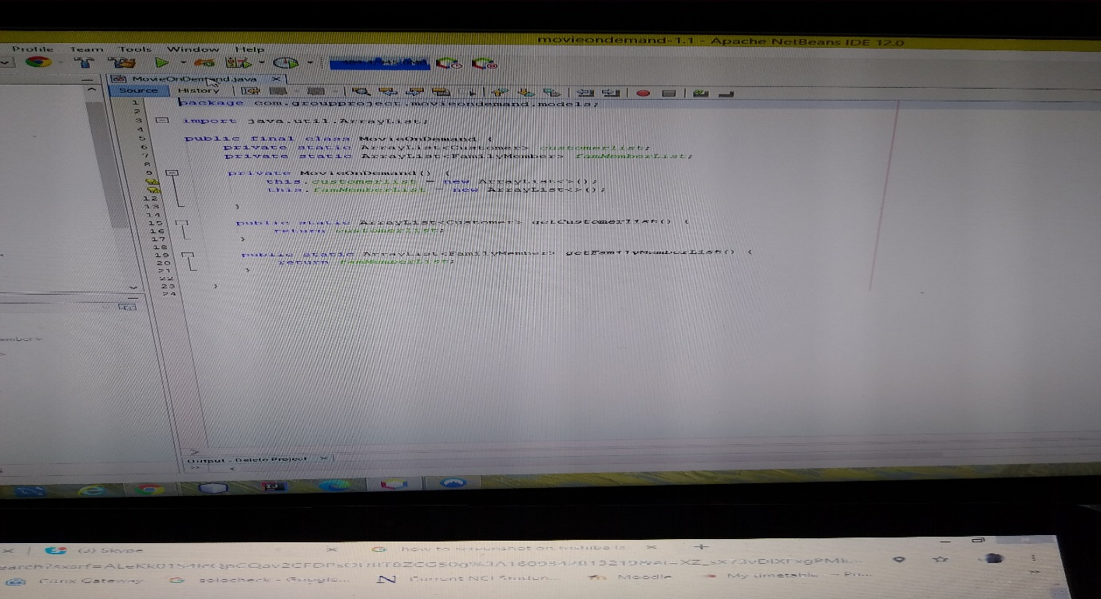

Now we shall move onto the Resources.

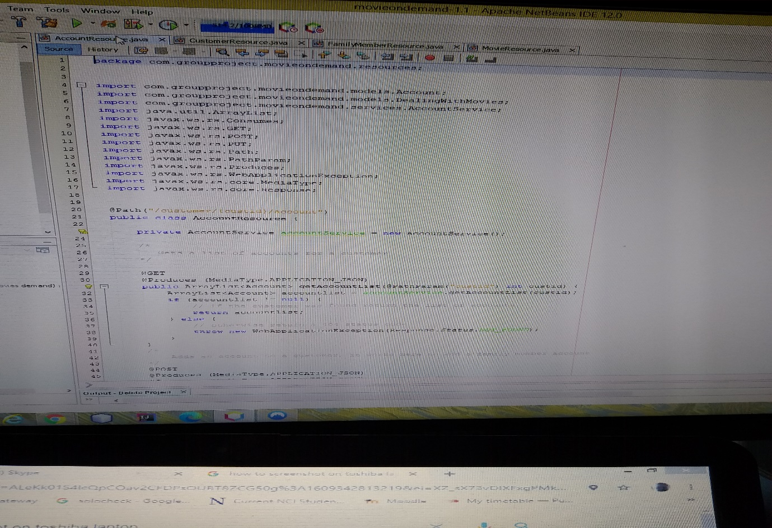

This is the account resource. It has an instance for the account service to call on the database. If the method calls on something null you will get a 404.It has the methods for get the account list with its URI. It’s a Get.

The next method is add account. It’s a Post. You can see the URI.

At the bottom of this page we have many other methods we decided to comment out. They cover all the requirements. It is our rough work which helped us get where we are. We have add a family member, add a movie, get the list of movies, delete a movie, add a customer.

See below.

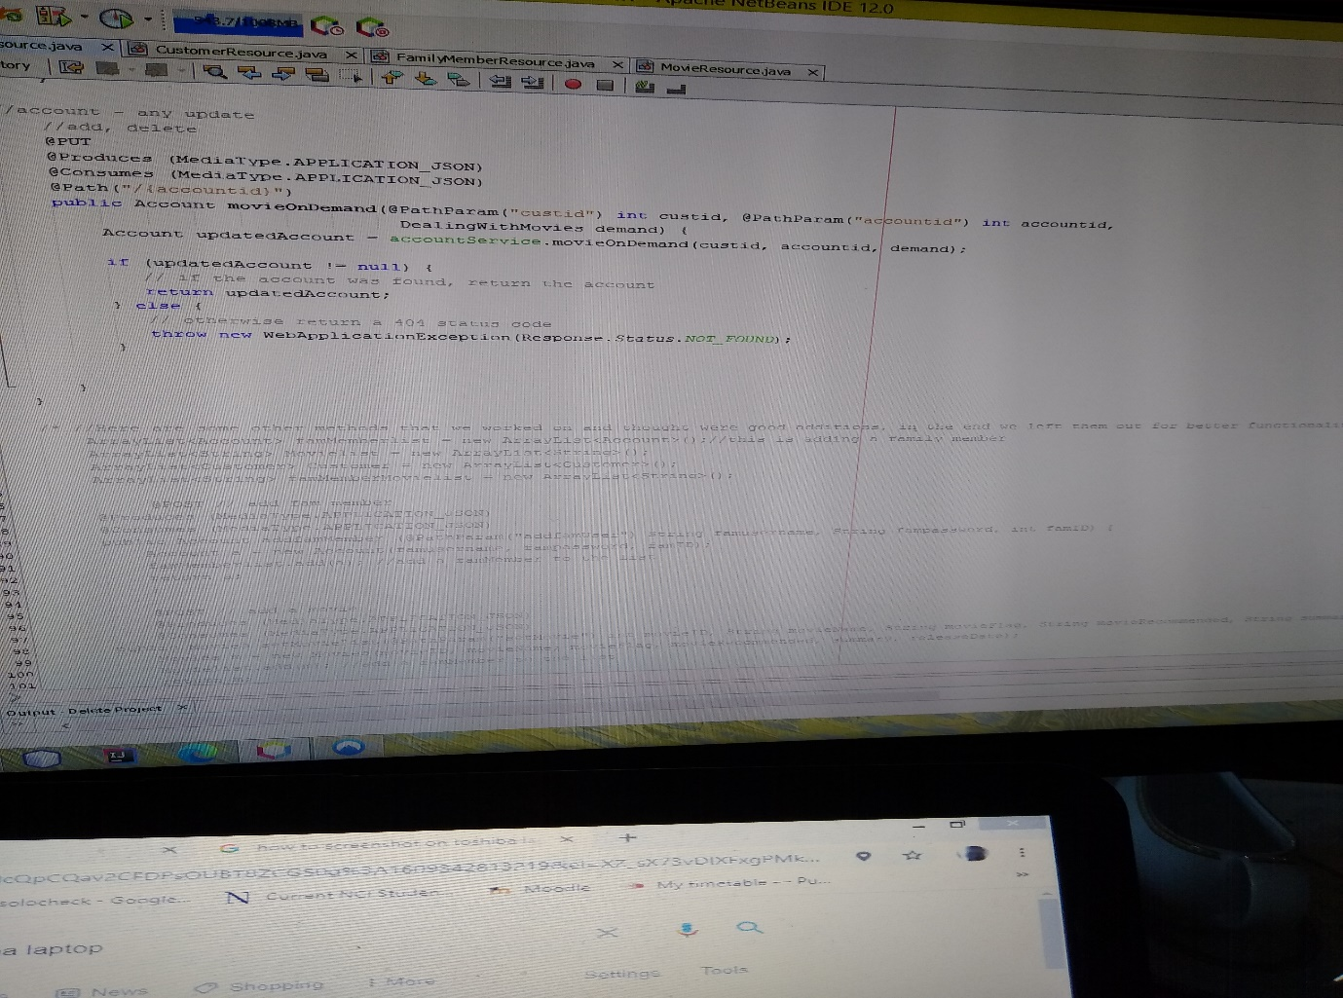

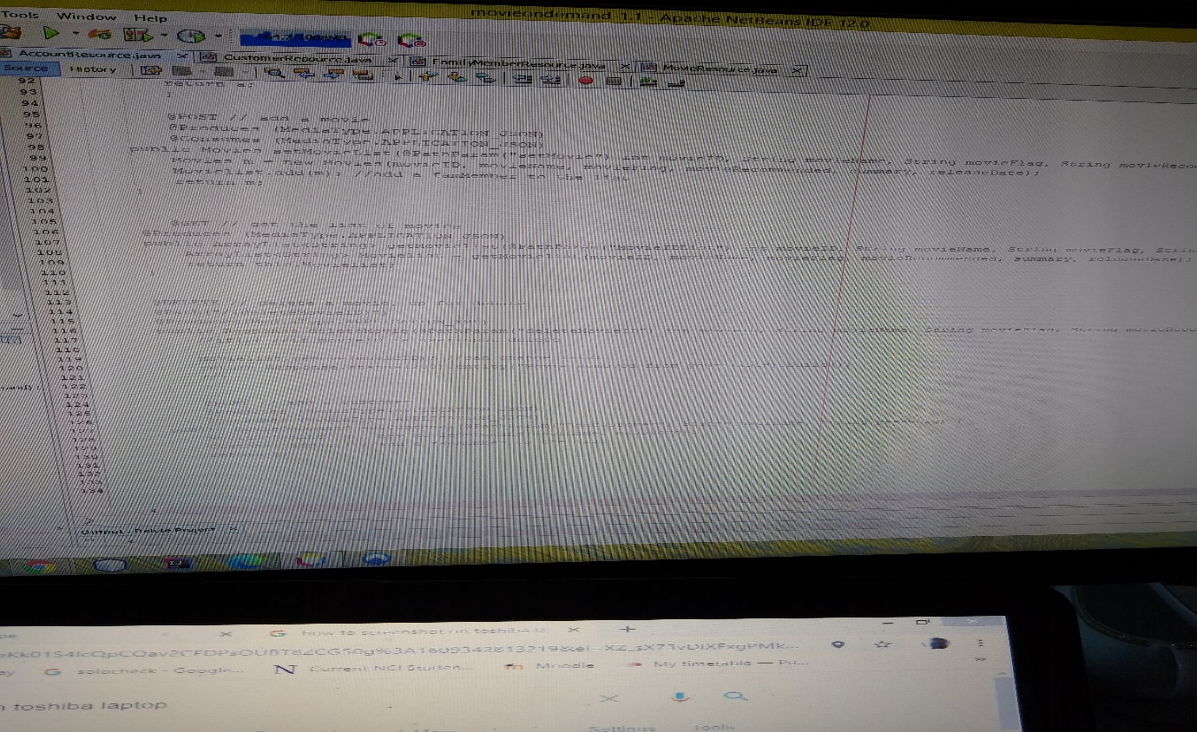

Next is the customer resource. This has the method get the customer list. It’s a get.

Next is the get the customer ID as getCustomer. You can see the URI. It’s a get.

The final method is to add a customer. See below.

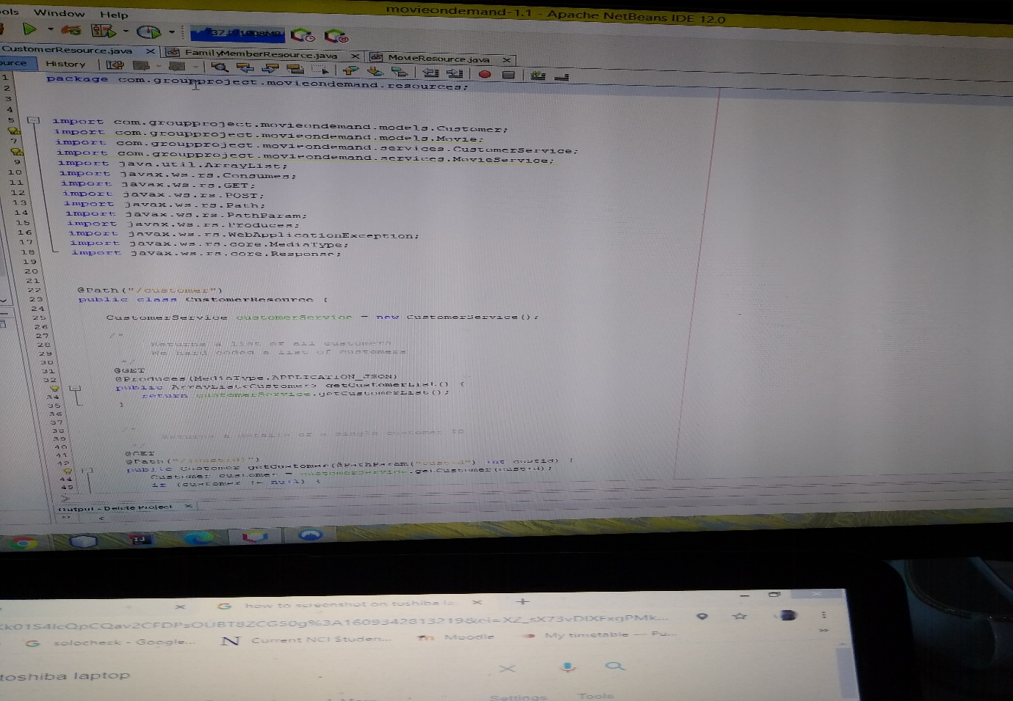

Next we have the Family Members Resource. Here we have the methods for getting the family member list. This calls on an array list.

We also have the method for getting the family member ID. Here you can see the URI.

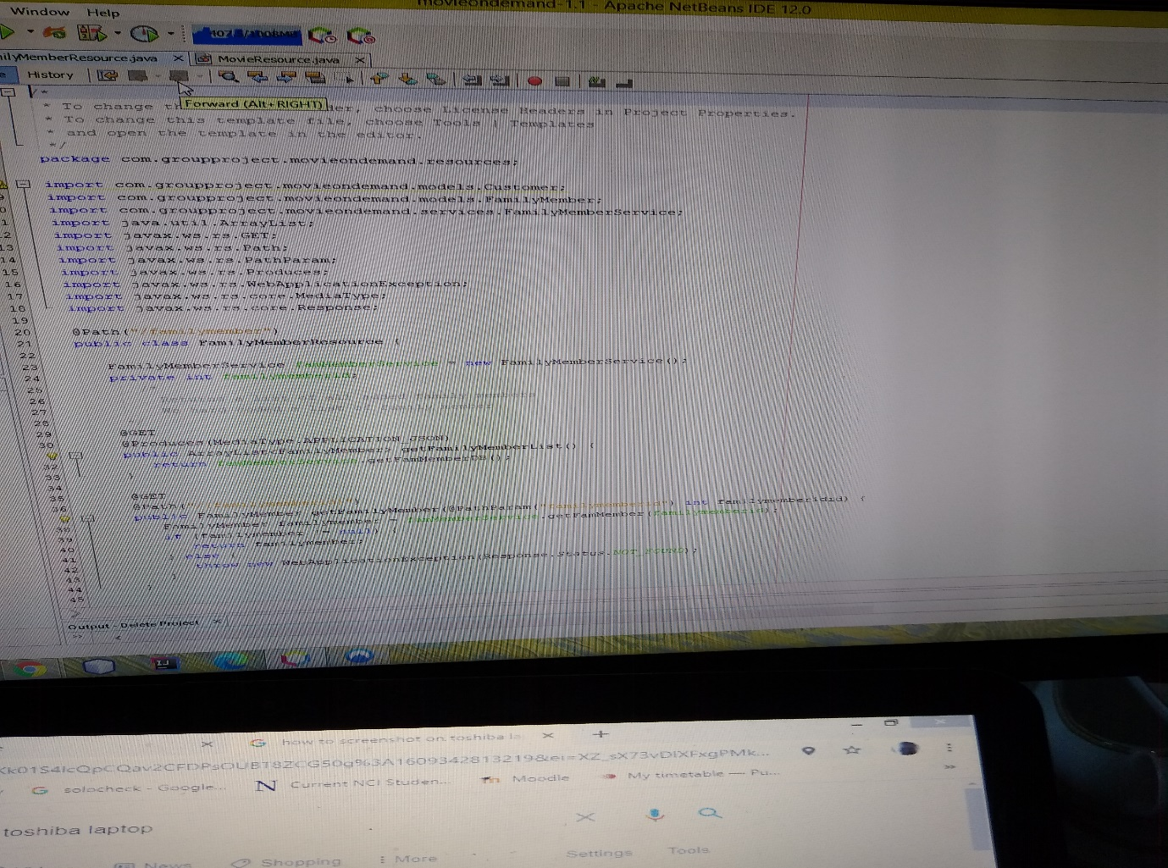

Next we have the very important movie resource.

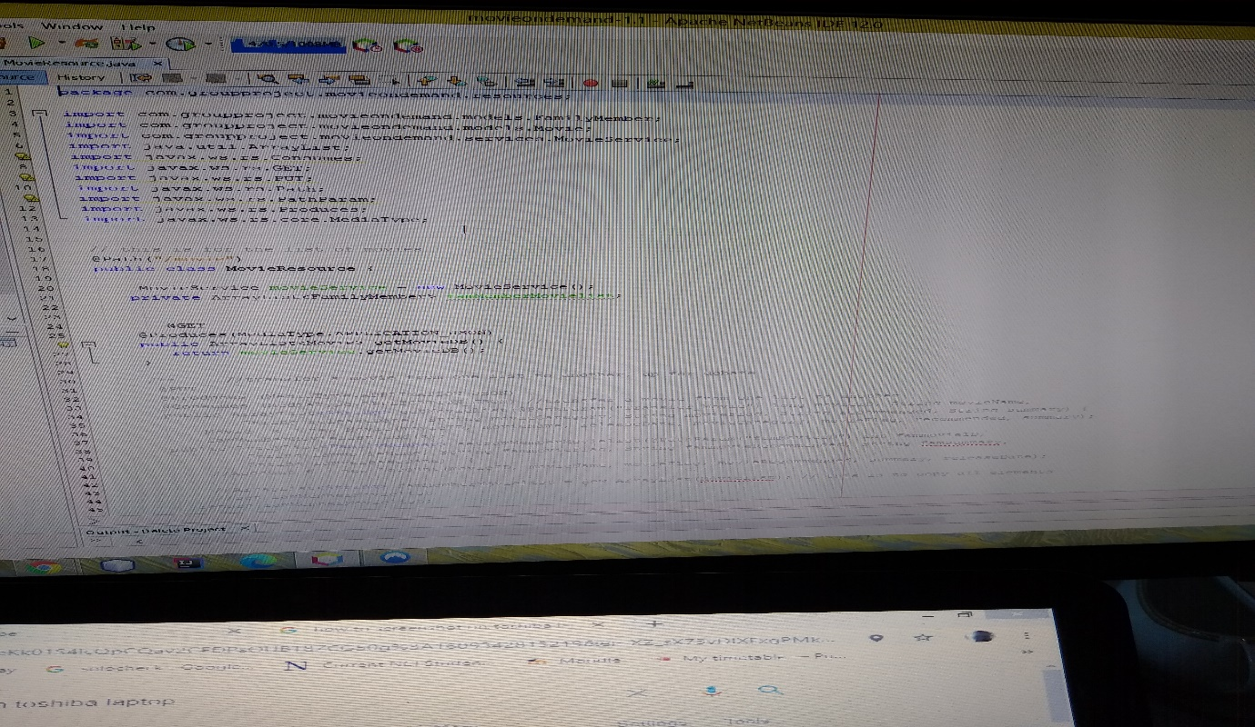

We can get the list of movies from the database here. We also have the family member movie list here too. See below we have the transfer movie method. We have it commented out to help the functionality of what we have. You can see it’s quite extensive and offers the options of copying all the movies and singular movies.

This concludes the resources.

Next we move onto the services.

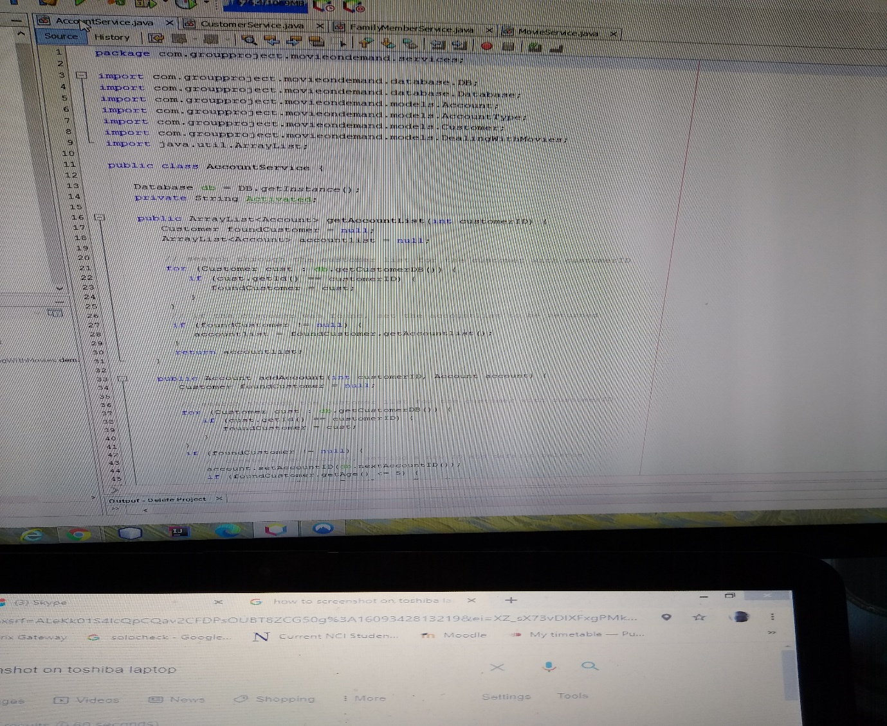

This is the account service class. We need a service for the resource. This is the base for the resources. We need an instance of the service in the resource. We 5 services. The account service, customer service, family member services, movies on demand service and movie service. The service has an instance of the database. It gets a list from the database. Each service is based on a model designed for it. Account service based on the account model. In this service it works with the account and the customer. It’s checking if the account exists. It goes through the for loop to find the customer by the Customer ID. The other services are based on the same principal. See below.

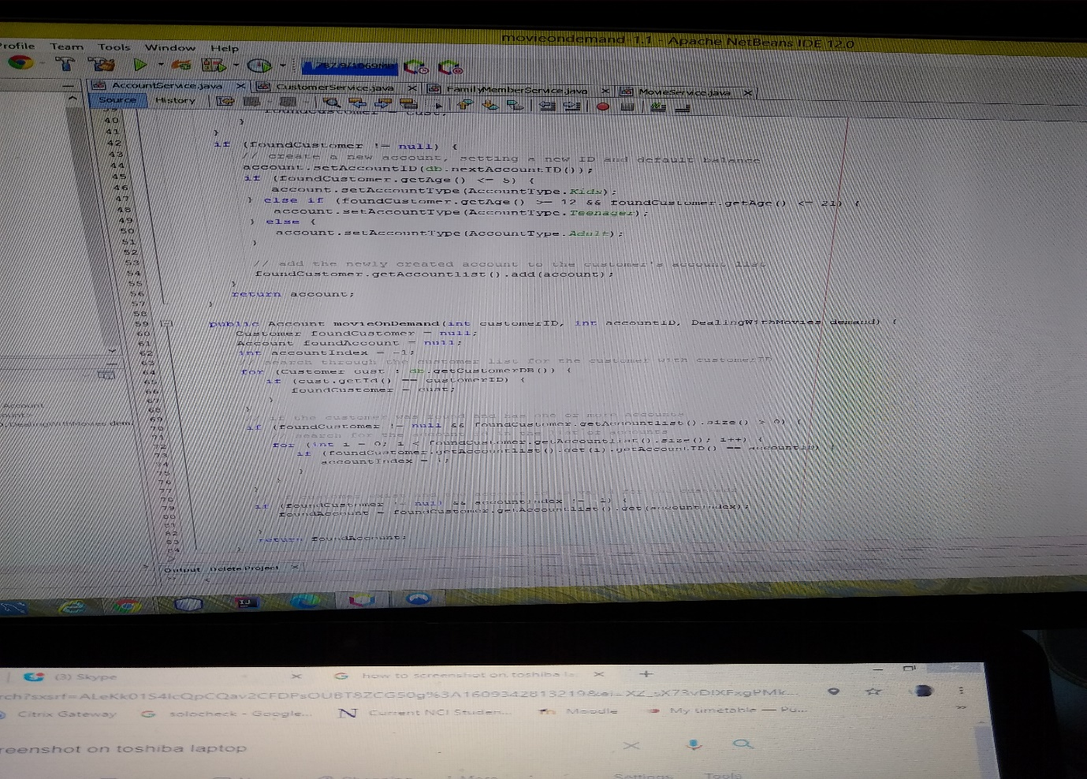

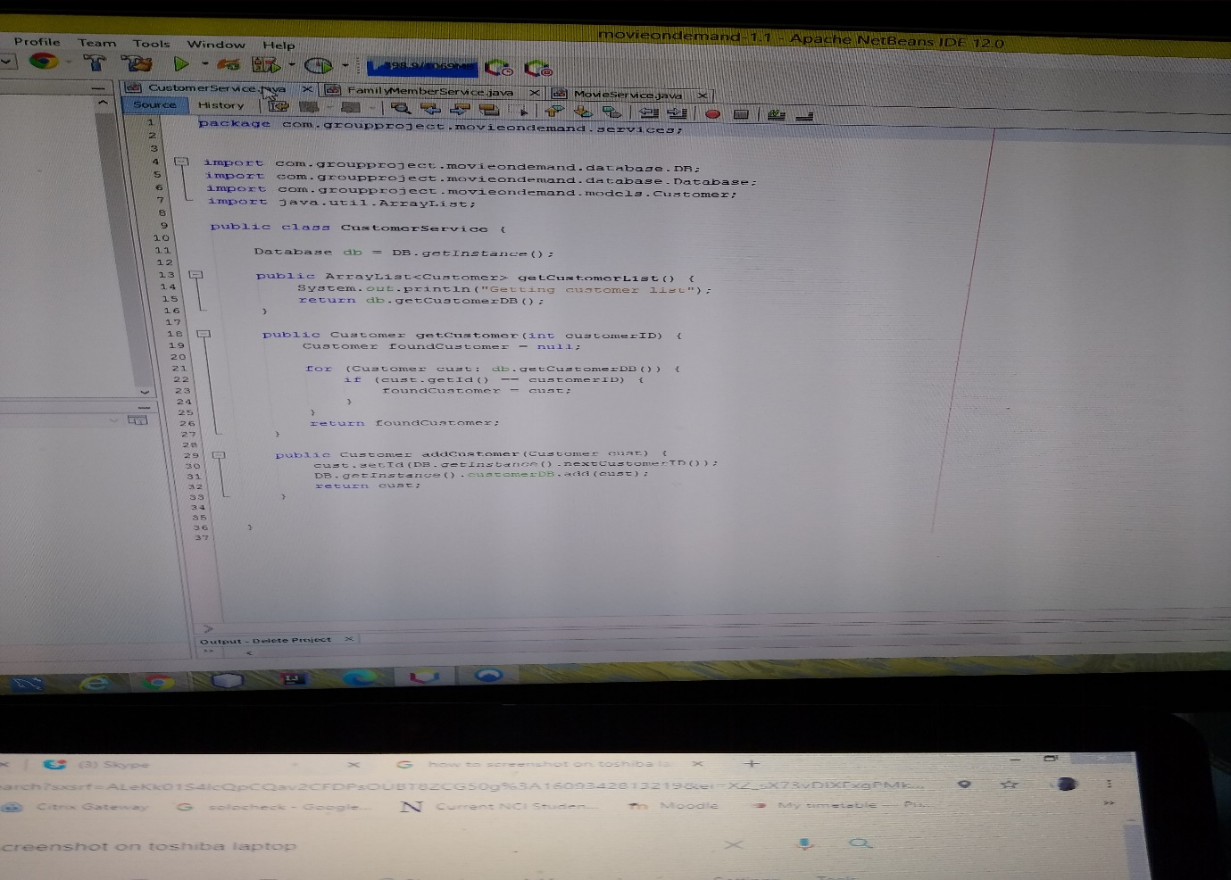

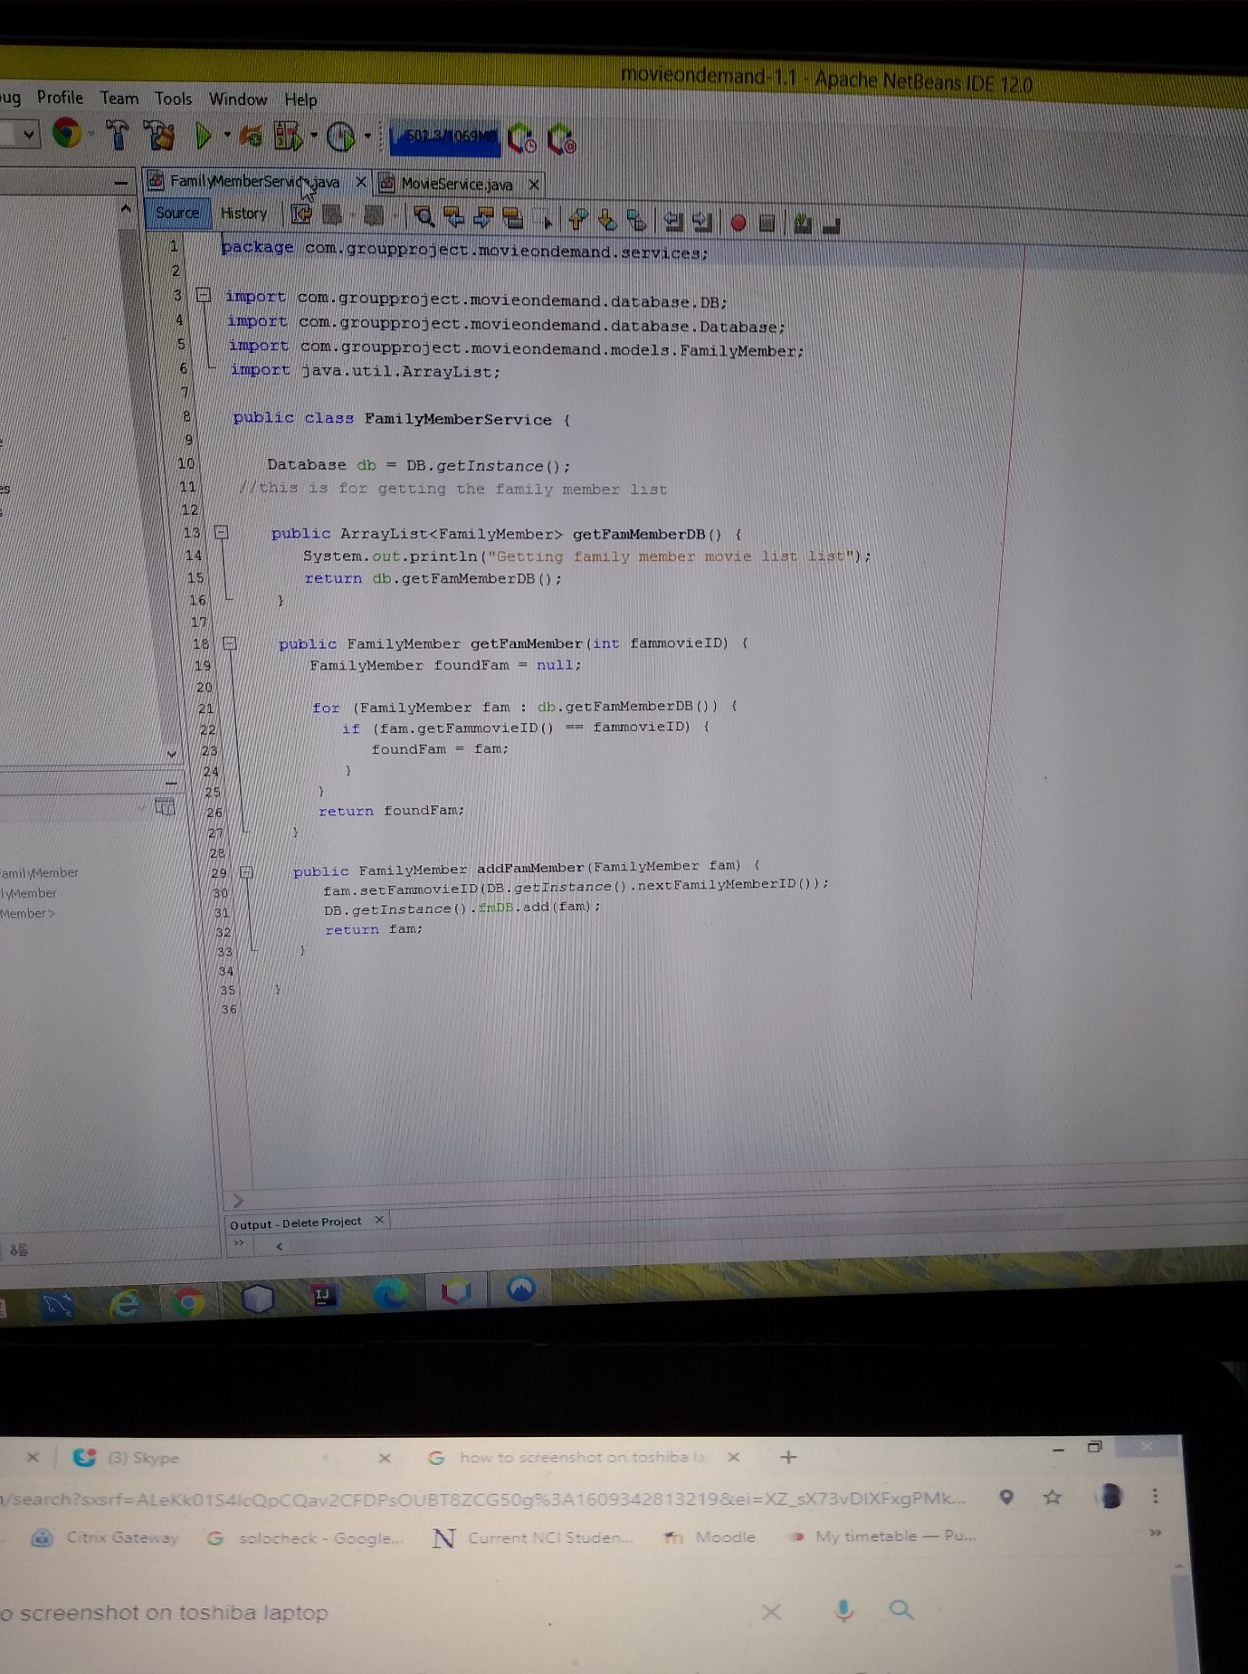

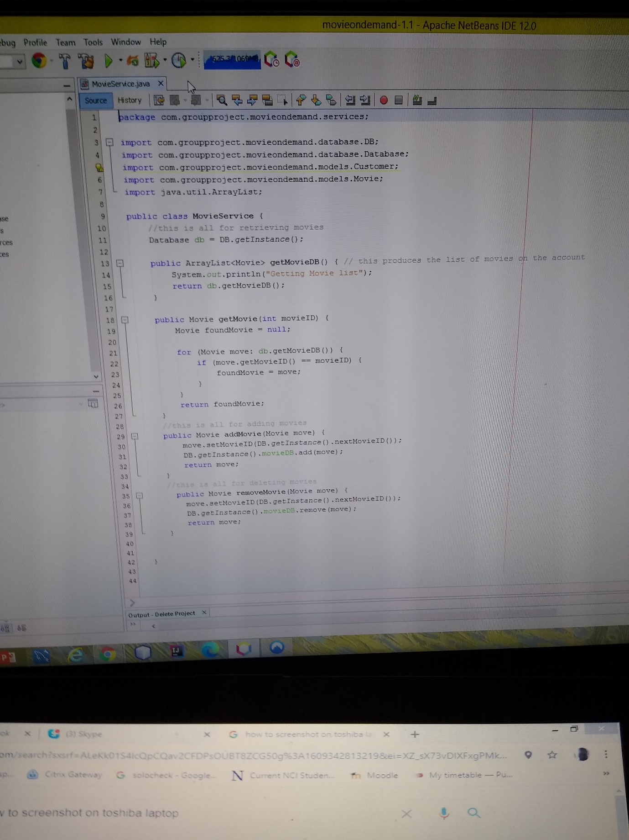

# Reference